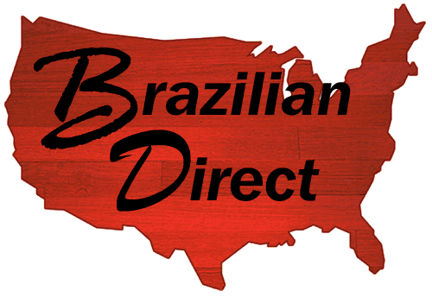
Celebrating 9 years of Quality Flooring
Thanks to our customers, we have grown tremendously since our start from a few individuals to a dedicated team. We are now one of the premiere suppliers of exotic hardwood flooring in the country today.
Brazilian Direct, Ltd., founded in May 2002 by Dan Cosgrove, brings quality solid exotic hardwood flooring direct to the USA, offering you the best value in the industry for Brazilian Cherry hardwood and many other South American hardwood flooring species.
Dan works as a liaison between floor manufacturers, marketing agents, architects and contractors, with the goal of providing quick and affordable installation and application of hardwood flooring and finishing systems for his customers.
About Dan
- Seventeen years of experience in the hardwood flooring industry selling floor finishing systems (Minwax/Dura Seal Division & Basic Coatings).
- Six years of experience selling hardwood flooring.
- Two years of experience working with one of the best importers in the industry, WFI Wood Flooring International.
- Extensive knowledge of exotic species imported from all over the world, and of coatings applied to the South American hardwood flooring species.

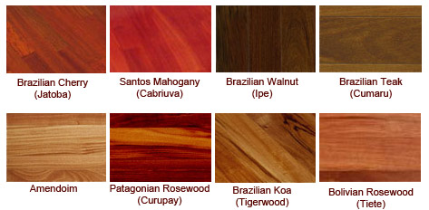

Featured Flooring Installations
Brazilian Direct has a history of excellence, providing hardwood flooring for some of the best installations in the country. Click below for more detail on our favorite installations below.
- St. Isidore's Parish - NWFA Floor of the Year, Best Pre-Finished Application, 2006
- Constellation Floor - NWFA Floor of the Year, 2004
 | E-Mail: | info@brazilianhardwood.com
 | Phone: | 888-452-8622
 | Fax: | 888-246-1964
 | Address: | Brazilian Direct LTD  1076 Kile Circle  Quakertown, PA 18951

